**Stepper motor 28BYJ-48**

* Blue wire: coil 2
* Pink wire: coil 1
* Red wire: common
* Orange wire: coil 1
* Yellow wire: coil 2

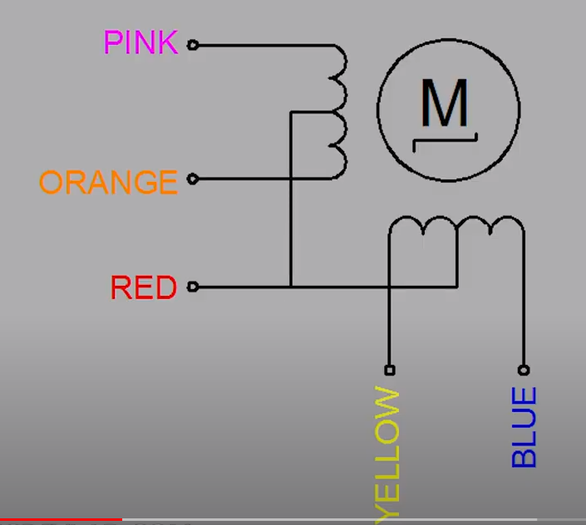

Make it compatible with NEMA stepper motor connection:

1. Open blue part on motor
2. Solder out the red wire (middle top soldering)
3. Destroy the connection of the red wire